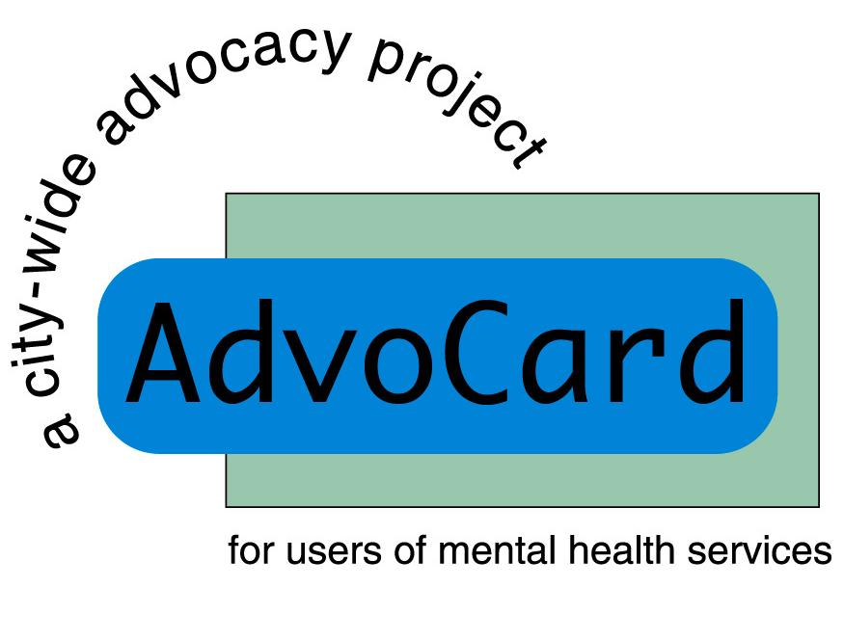
AdvoCard is looking for new Board Directors

AdvoCard is on the look-out for some brilliant new Board Directors to support the organisations next stage of its journey.

About us:
AdvoCard is a well established independent advocacy organization primarily serving people with experience of mental ill-health in Edinburgh. We provide opportunities for people to participate more effectively in decisions that affect all aspects of their lives.
Individual advocacy – trained volunteers and paid workers assist people around the wide range of issues that affect their lives. AdvoCard has offices serving both community-based service users, as well as hospital inpatients.
Collective advocacy – AdvoCard supports groups of people who use mental health services. The group members support each other, as well as campaigning on common issues

Last year we provided advocacy for 911 individuals. However the needs in society for our services are increasing. To meet this we have recently extended our service to work in the prison and also have developed a specific service to respond to welfare reform.

About the role:
The Board is integral to the existence of AdvoCard. Collectively, its members provide strategic support and guidance for the ongoing development of the organisation. Board Directors are also Trustees of the charity, meaning they are responsible for ensuring it is solvent, well-run and meeting its charitable objectives.

About you:
Ideally, new Board Directors will have expertise in one of the following areas:
- Finance: experience in voluntary sector finance and/or accounting.
- HR: knowledge of legislation, contracts etc
- Business management: particularly strategy and partnership development
We welcome all enquiries, and will provide induction and training as required.
Commitment:
- Attendance and active participation at our regular Board meetings, which are currently every 2 months during the day.
- Active participation in one or more of our sub-groups: Finance, People, Marketing & Communications or Development.
- Attendance at our annual AGM
The total commitment is an average of ½ a day per month. In return we offer a highly rewarding role and all travel expenses.
Get in touch:
We’d love to hear from you. For more information or an informal meeting contact Chris Mackie, the Director, chris@advocard.org.uk www.advocard.org.uk or on 0131 554 5307

